30.6: For a toroidal solenoid, 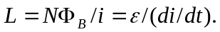 So solving for  we have:
